1.5 I can identify and respond to inappropriate content and behaviour

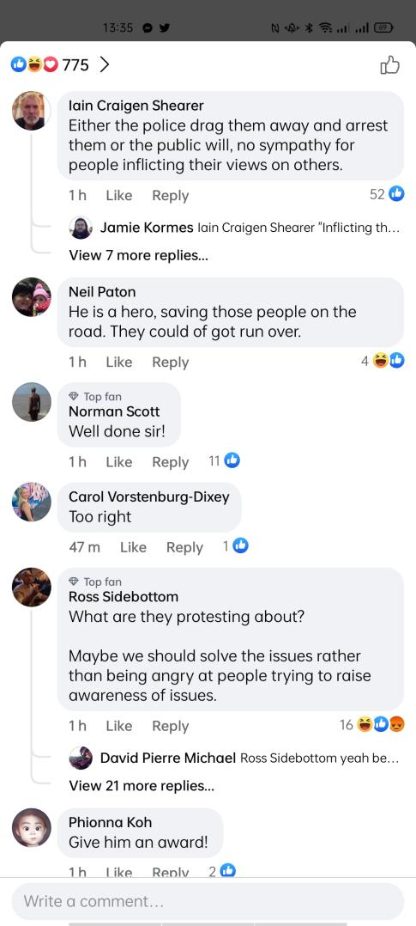

[Above shows a screenshot from a Facebook comment section on a post on some protesters]

The above photo shows the variety of comments that posts on Facebook and other venues can receive, some good and some questionable. Some may need reporting and some may want to be addressed by the moderators.

Some sites have rules posted on the site before you make a comment, like the one below:

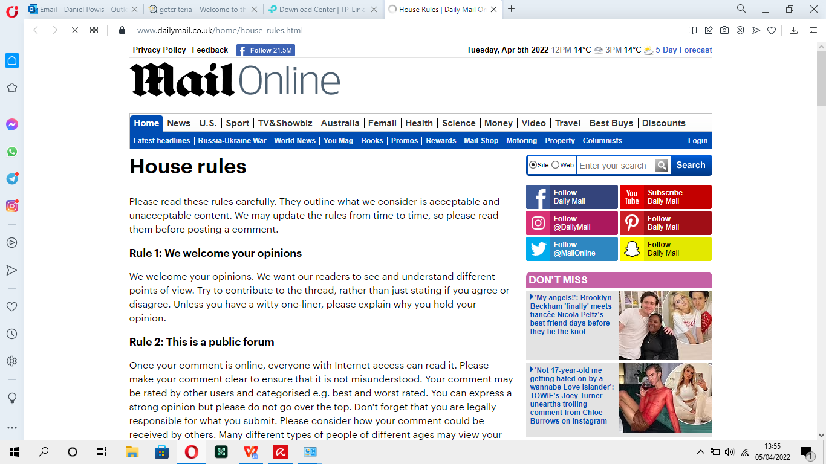

[Above shows the screenshot of the ‘house rules’ from the Daily Mail]

With acceptable policies: companies must abide by software and hardware policies, they must follow the rules set by the owner of the software and hardware. This means that people can be monitored of what they use and what they search when they use the companies/universities computers/network. Websites like Dailymail and The Sun etc will have a Webmaster.

Webmasters will also monitor potential threats to website like hacking and comments that might need removing.